APPENDICES

Appendix 1.
My method
The Bullet Journal Method is built off seven core concepts:
- Index – where you log anything you want to track and find later
- Key – how you quickly figure out the status of a project or item
- Future Log – a list of things that will happen in the future, by month
- Monthly Log – a list of things that need to happen this month
- Daily or Weekly Log – what will happen today and notes about today
- Collections – buckets of similar information (to-do list, vacation planning, reading list)
- Migration – the process of going through your journal, seeing what tasks you didn’t complete, and deciding what to do with those tasks.
Each of these concepts helps reduce cognitive load.
I am in my bullet journal nearly every day, and while I am working, it stays open on my desk almost all day. I take about five minutes each day to look at my Outlook calendar and review what I need to do, write it down in my bullet journal, and then begin with the first task on my list. As I complete tasks, I check them off.
Table 1 is what a typical week might entail with my bullet journal:
Task | M | T | W | T | F | S | S
Look at my Outlook calendar to review what I need to do | x | x | x | x | x
Write out what I want to do today (and check off items as I go) | x | x | x | x | x
Document what happened over the weekend (I tend to forget) | x
Conduct Weekly Planning Meeting |  |  |  |  | x
Reflect on the week |  |  |  |  | x
Set up next week |  |  |  |  | x
Total time spent | 10 | 5 | 5 | 5 | 50 | 0 | 0
Table 1. Overview of time needed with a bullet journal based on day of the week.

As previously stated, I take about 30 minutes each week to hold a Weekly Planning Meeting – this is what keeps me on track, and perhaps what keeps me using my bullet journal and being intentional about my work. I have a really good idea of what the week ahead will look like (barring any true emergencies). The Weekly Planning Meeting breaks down into three pieces:
- Skeleton (5 minutes): I open my calendar and take 5 minutes each week to figure out the skeleton of my responsibilities (e.g., things I have to do – like be home for the bus, take a kid to a doctor’s appointment, teach a class).
- Brain dump (15 minutes): I write, long hand, and as close to stream-of-consciousness as I can get, all the tasks for the next week that I need to accomplish. Sending emails, wrapping up projects, prepping for a class, prepping for a conference, following up on a message from my kid’s teacher: it all goes into my brain dump. This is also a time I might look over the last week and see what I didn’t accomplish.
- Task assignment (or “tasks meet time”) (10 minutes): I look over my list, prioritize as necessary, and add it to my calendar, assigning a chunk of time to each task. When assigning your chunks of time to a task, a good rule of thumb is to take the amount of time you think you need (it’ll take me 10 minutes to write that email!) and schedule three times longer than you first estimate you will need (so give yourself a generous 30 minutes for that writing task). I also add in breaks, lunch, any travel time (I’m on a large campus), and “catch up” time.
As part of my Weekly Planning Meeting, I give myself 10 to 15 minutes to reflect on the past week. The questions I pose to myself have changed over time and as my own needs and interests have shifted, but I commit to spending a few moments to think about the past week, what I’ve accomplished, and what I might need to adjust for the coming week. See Appendix 3. Examples of Reflective Questions for some ideas. I also spend a little time documenting my accomplishments.
Figure 1 shows an example of a Weekly Planning Meeting, including my prompts for reflection. Above and below the “Weekly Planning Meeting” box, you’ll also see examples of a “Daily Log” for the dates January 10 and January 11.
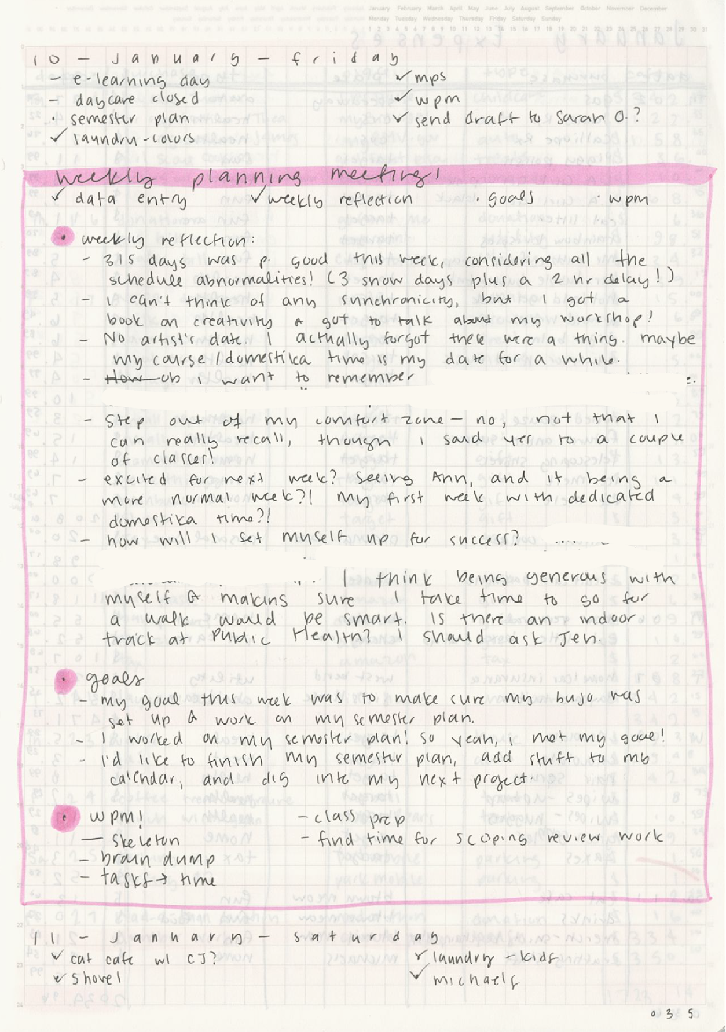
Figure 1. Page from my bullet journal. Includes a Daily Log for January 10, a Weekly Planning Meeting with reflections, and a Daily Log for January 11.

There’s a lot more you can do with a bullet journal, and many adaptations you can make to fit your needs. For example:
Adapting the Monthly Log to fit my needs. My Monthly Log has been through many adaptations through time. My current layout is below, which captures a balance of what I need to know about and what I’ve accomplished. On the left-hand page is information related to what I need to pay attention to this month, what I want to accomplish this month, and what I need to be aware of for next month. On the right-hand page is information related to things I’ve completed, so information for my annual review (see Figure 3), and my habit tracker (see Figure 4).
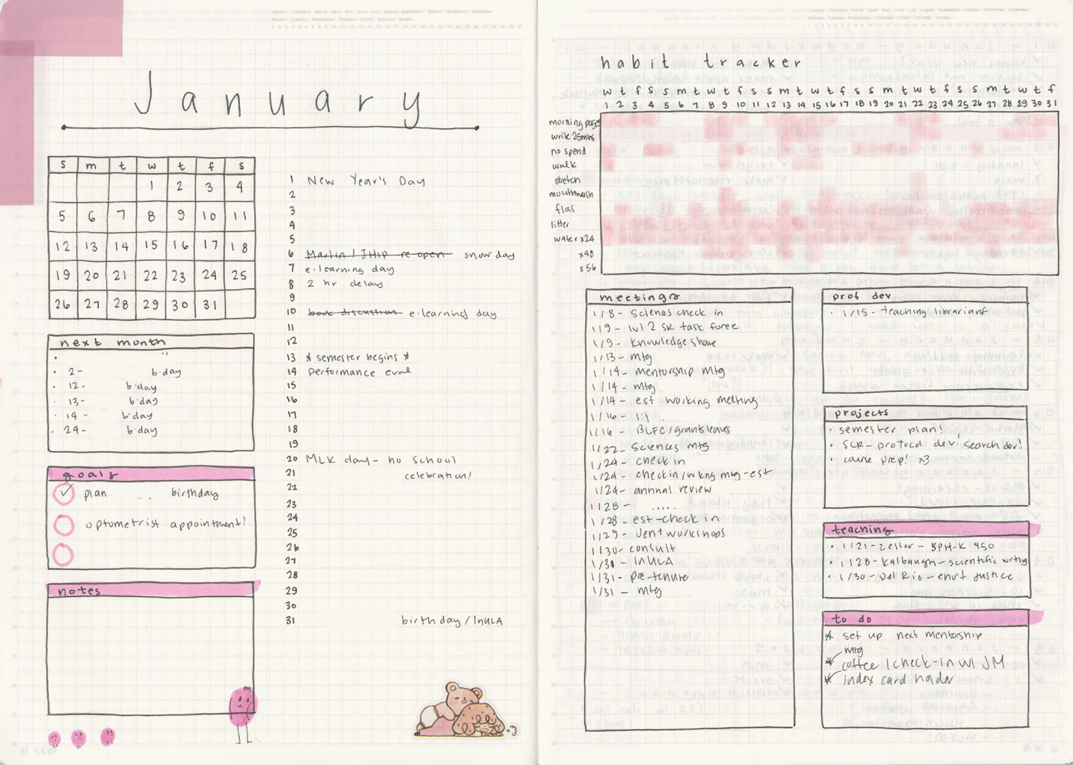Figure 2. Two page “spread,” which includes the information I want to track for the current month and the following month (left page) and information for my annual review process and personal tracking information (right page).

Information for my annual review. As part of my practice of reflecting on my previous week, I go through my bullet journal and add information to a section of my Monthly Log that captures what meetings I’ve attended, professional development opportunities I’ve taken, what projects I’ve worked on, and when I’ve taught. See Figure 3, below, which is part of my modified Monthly Spread (also known as a Monthly Log). Again, this fits my needs and has been modified over time.
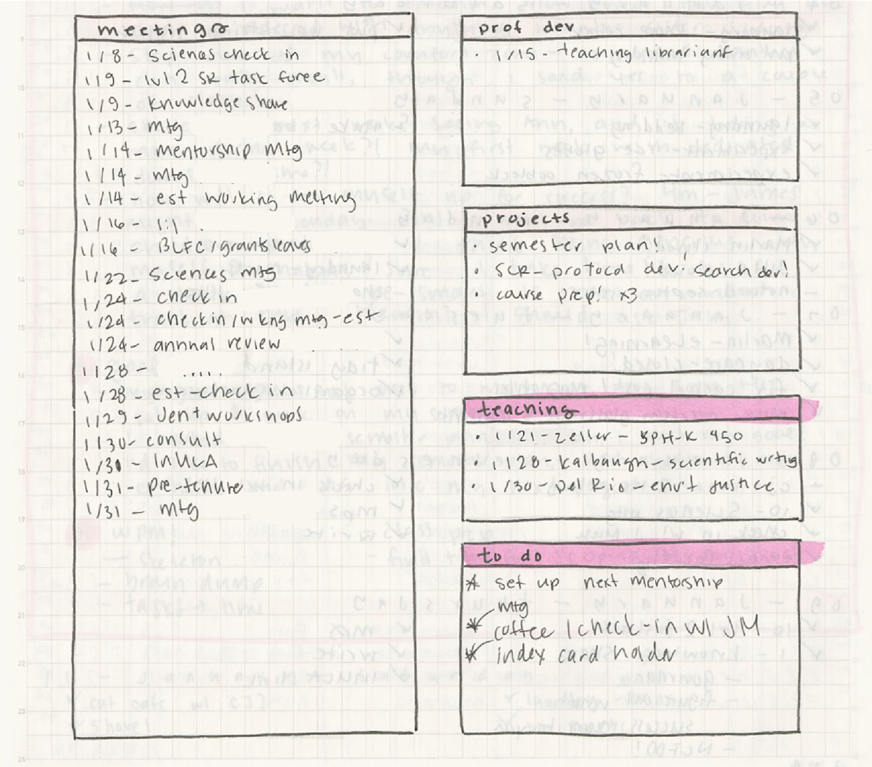
Figure 3. Close up of a portion of the Monthly Spread dedicated to tracking information that will ultimately be part of my annual review. Specifically, the items in the boxes labeled "Prof Dev" (shorthand for “Professional Development”), "Projects," and "Teaching" are sections that I must report on as part of my annual review. “Meetings” acts as a handy reminder of what I’ve accomplished; “To Do” is a catch-all section for those odds and ends that pop up during the month.

Habit tracking. Habit trackers are straightforward ways to track habits. I fill in each box as I complete the associated item. Items I track change over time – but some, like the amount of water I’m drinking, have been consistent over the years. I add a habit tracker as part of my Monthly Spread, but it could go anywhere.
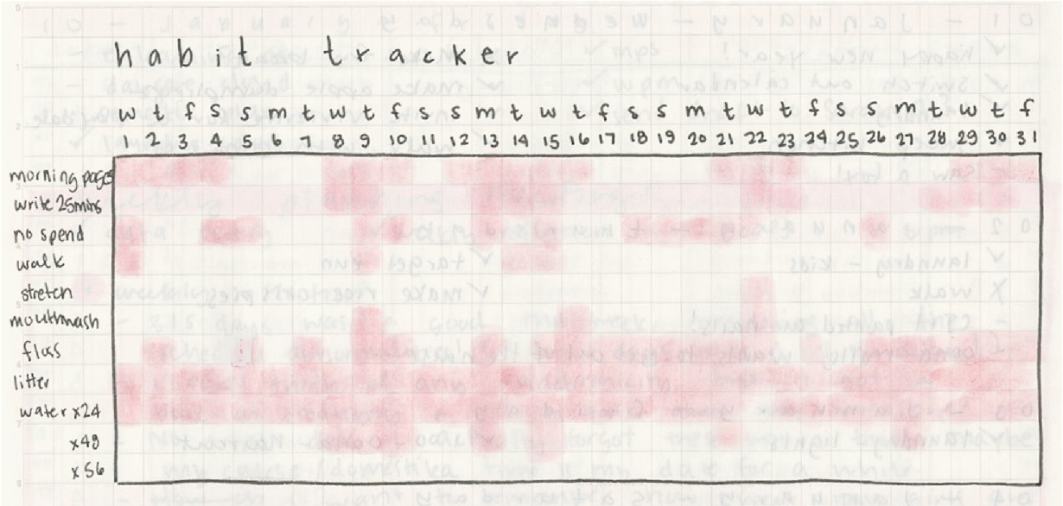
Figure 4. Example of a "Habit Tracker." This is updated by filling in a square on the grid when I complete an item in the tracker. E.g., if I went for a walk that day, I fill in the square.

Brain dumps. When I feel overwhelmed – I use a Brain Dump! I write out everything on my mind, then work to prioritize.
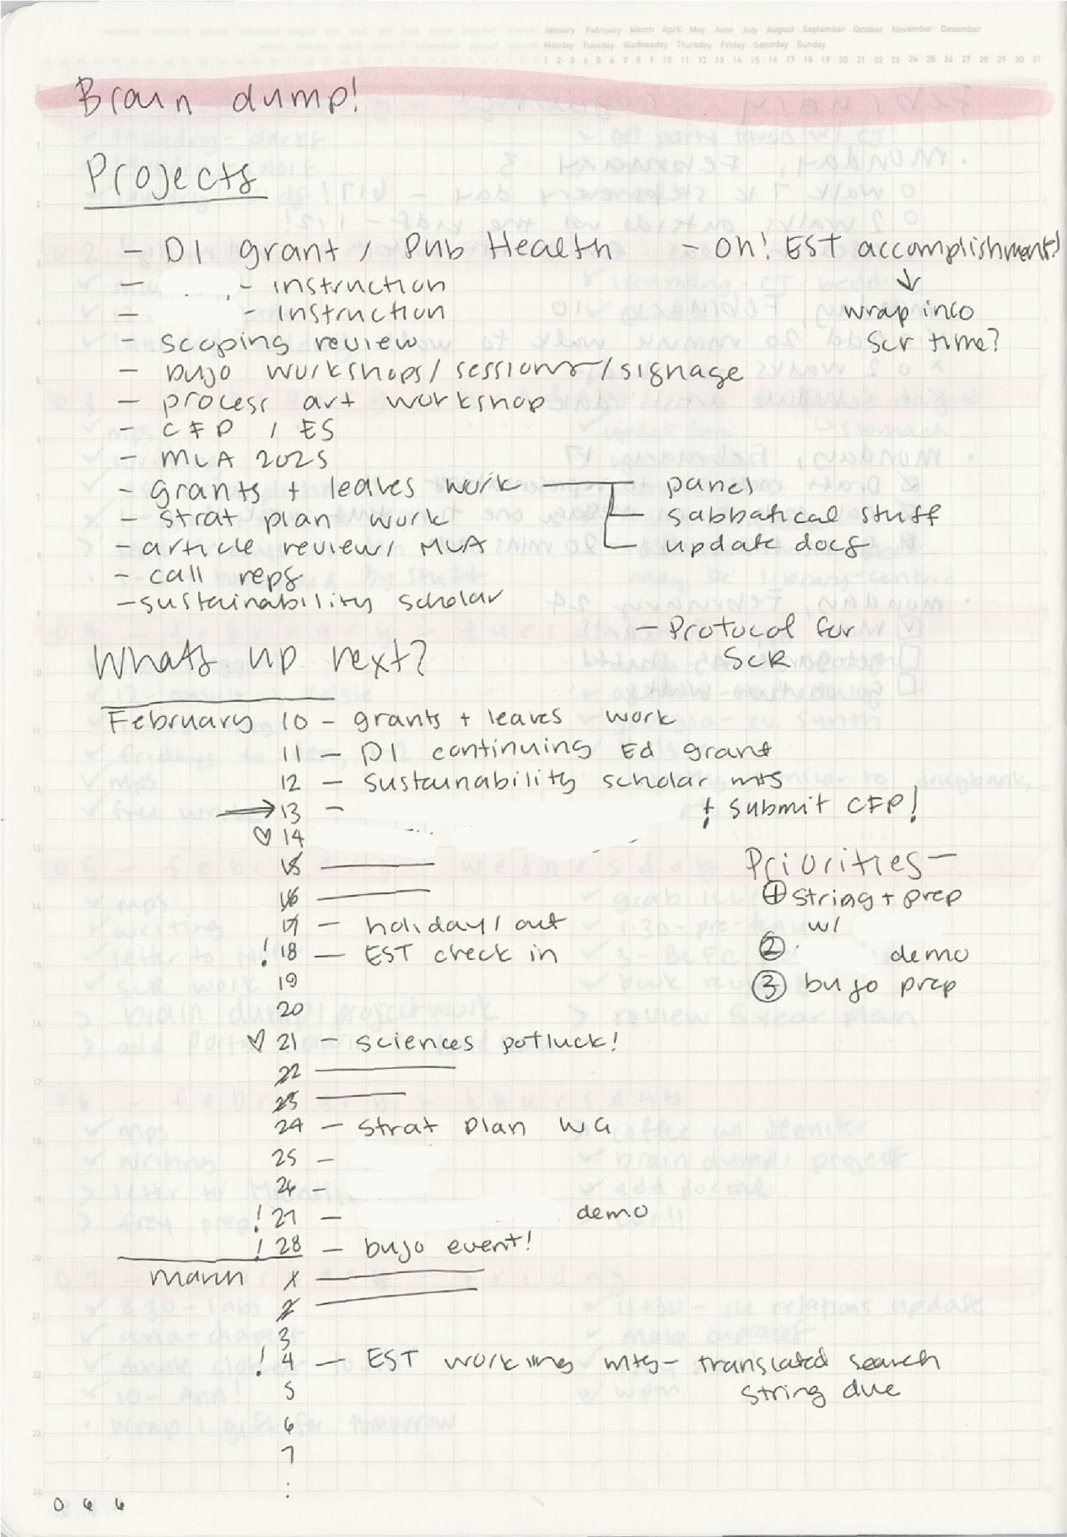
Figure 5. Full page titled "Brain Dump!" followed by a list of projects and an overview of a calendar listing deadlines.

Course tracking. You can use your bullet journal to track anything! For example, I created a way to track my very slow progress on some courses. You can see some of the courses are written in pencil – I haven’t decided on the exact order I want to take the courses in.
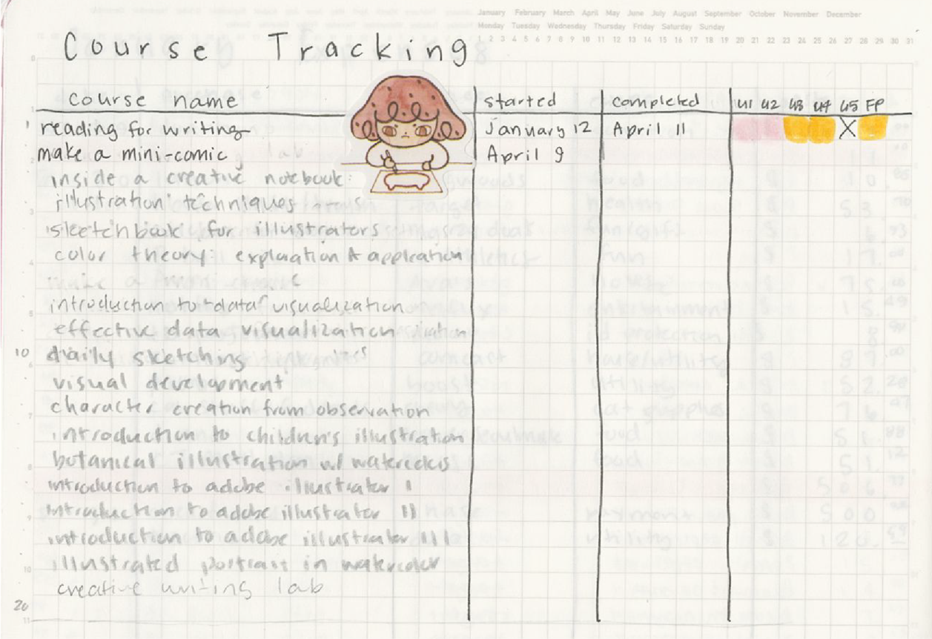
Figure 6. Four column table used to track course progression. The columns are titled, "course name," "started", "completed", and the final column is sub-divided into units 1 - 5 and a final project ("FP"). There is also a decorative sticker of a person doodling a picture of a cat.

Remember: these are just a few examples of what you can do with your bullet journal. Ultimately this is a tool for you – try out new things, see what works, toss out what does not.

Appendix 2.
The Semester Plan
My Semester Plan lives in my bullet journal, as well. I like having my Semester Plans at the beginning of my journal – it makes it feel more prominent. But, like anything, when you use the Index you can have a Semester Plan anywhere in your bullet journal. This is just what I like to do!
I give myself one- or two-days’ time to really dig into my ideas for the upcoming semester. This is a generative practice, so I do better with a dedicated block of time. The NCFDD has a great pre-recorded workshop on this topic, so if you are intrigued by Semester Plans, be sure to check it out.
Figure 7 and Figure 8 show my process and layout for a Semester Plan.

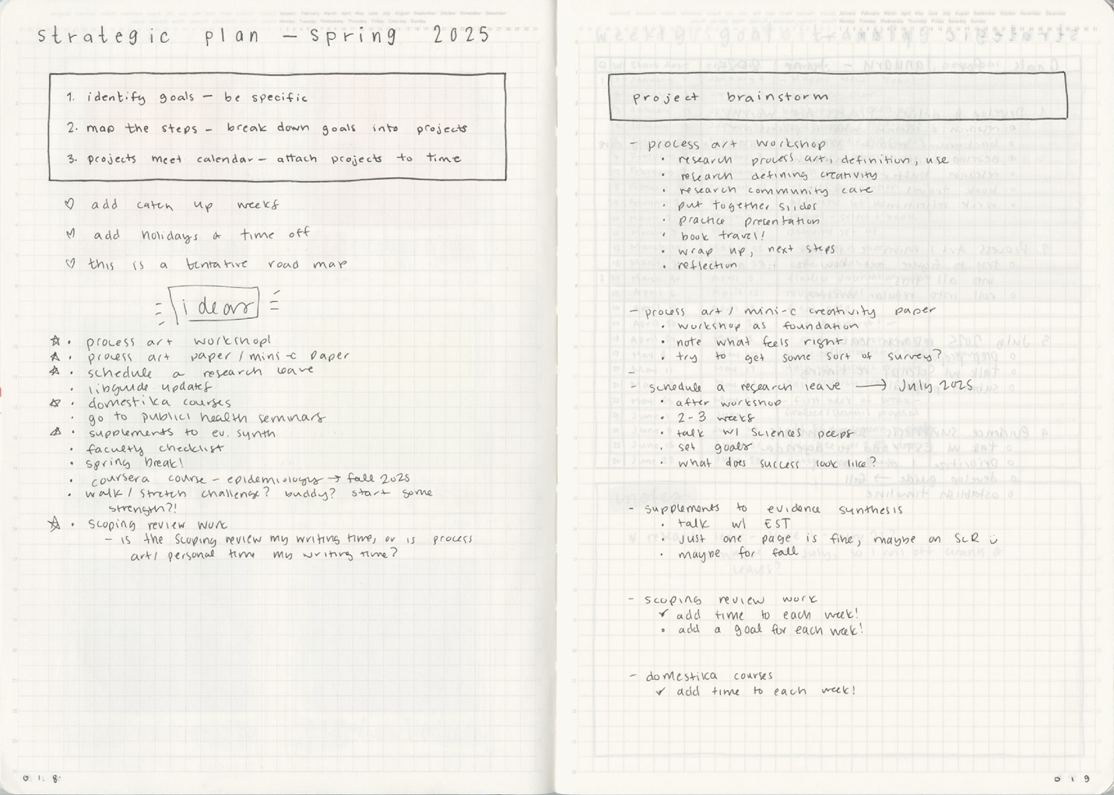Figure 7. Part 1 of 2 of my Strategic Plan. I use these pages to generate ideas.

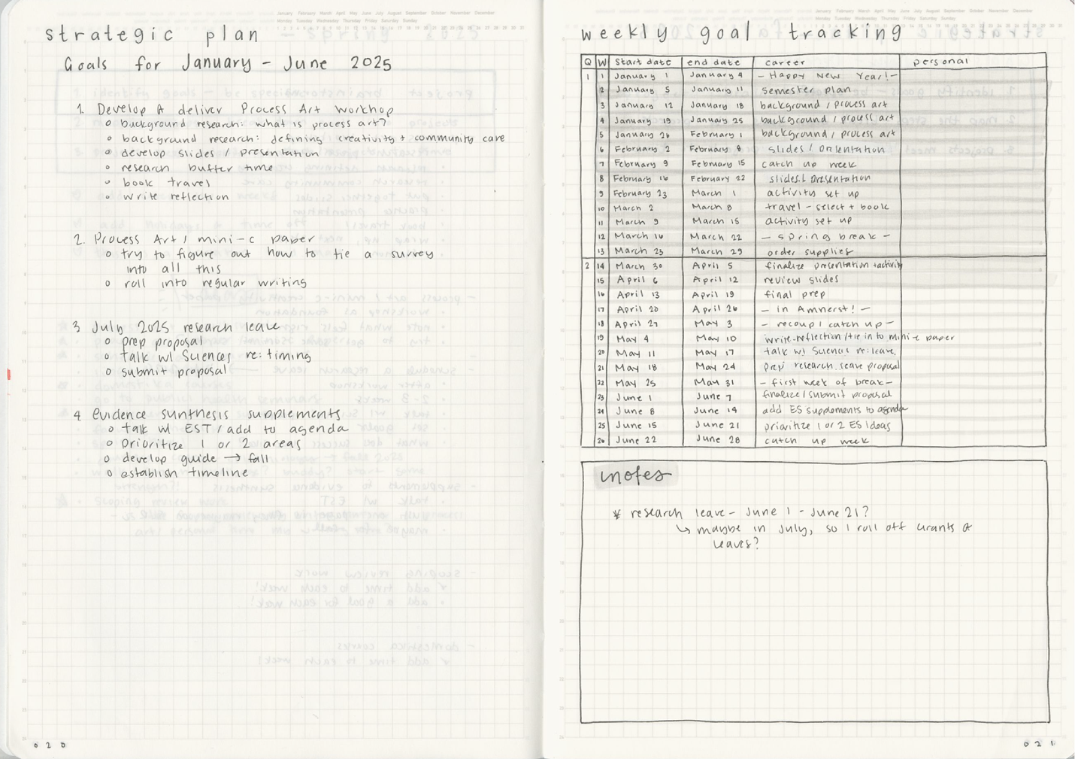Figure 8. Part 2 of 2 of my Strategic Plan. This stage is generating the “formal” plan and adding tasks to weeks in my calendar. After I complete this step, I add tasks to their associated week to my Outlook calendar.

Appendix 3.
Examples of Reflective Questions
Part of my Weekly Planning Meeting includes a few questions to myself reflecting on the previous week. The questions I use have changed over time and align with what I want to focus on or improve.
Here are a few examples:
- What one thing do I want to accomplish next week?
- What is one thing I did that I am most proud of?
- What is one thing I want to remember about this week?
- What was the most challenging thing this week, and how did I handle it?
- How well did I take care of my physical health this week (exercise, nutrition, sleep)?
- Did I step out of my comfort zone? How?
- How did I connect with others and nurture relationships?
- What support or help do I need to make next week easier?
- What one thing do I want to accomplish next week?
- What am I most excited about for next week?
- How will I set myself up for success?

Appendix 4.

Additional Resources

- Weekly Planning Meeting/The Sunday Meeting:
  - https://www.insidehighered.com/advice/2010/09/20/sunday-meeting
  - Written by Kerry Ann Rockquemore, founder of NCFDD.
- Semester Planning:
  - https://web.archive.org/web/20100121081334/http://www.insidehighered.com/advice/winning/winning1
  - Written by Kerry Ann Rockquemore, founder of NCFDD. (Note: this version is from the Internet Archive.)

Appendix 5.
My supplies (current as of this writing)
Because part of journaling is the supplies, I want to share my supplies list. I’ve spent a lot of time figuring out exactly what I like to use, and this is what works for me. I get most of my stuff from the JetPens website.
Day-to-Day Use:
- Journal: Stalogy 365, grid. The grid pattern is a light gray, 4mm apart. The thin pages make this easy to carry around, and you can get a lot of content into the journal itself. I’ve gotten up to two years out of one journal, but, some folks are frustrated by the bleed-through (aka “ghosting”) you get between pages. I prioritize the weight and quantity of information I can get into my bullet journal over how pretty it looks.
- Writing instruments:
  - Multi-pen – 4 compartments. I use a combination of different colored gel pens. I specifically use a very fine-point pen: uni-ball sigma 0.28mm.
  - Mechanical pencil – Pentel Orenz, in 0.3mm.
- Correction tape: Pentel petit-corre 2.5 mm
- Tombow Brush pens: Over the years, I’ve collected all 108 colors. I use these to visually separate my days and highlight when I’m taking notes.
- Pencil case: to carry it all around in! I keep looking for smaller and smaller options. I previously used the Raymay clam pen case, because they are long enough to carry my Tombow pens. I recently started using the Velos Tin Pen Case – Flat, which is also long enough for my Tombow pens, but only has room for about five things total.
- Stickers: I like to flag my months. I currently use the Iromekuri sets from Sun-Star.

Other supplies of note:

- Archer and Olive journals – very nice and thick paper, so if you want to embrace your creative side and bust out paints and markers, this is the journal for you! But I only get about three months out of one of these journals and they are bulky. I opted for the dot grid paper type to give me a little guidance but not too much.
- Minimalism Art journals – from Amazon. A good starter journal – it was low-cost, was a size I liked, and had the dot grid. I got about six months out of these journals.
- Leuccheturm, Notebook Therapy, Scribbles That Matter, Rhodia, and Moleskin are all other popular brands.
- Rulers – I pop the very slim Midori Multi Ruler (30cm; or 11.8 inches) into my pencil case. It’s hinged, so folded on the hinge it’s only 16.5 cm / 6.5 inches in length. Handy for long lines! Midori is generally a company that makes its products easy to use, so the hinged design hasn’t impacted my lines.

Other tips and tricks
- “Ghosting,” or how much of your writing instrument you can see through the pages, is a common complaint. I don’t mind the minimal ghosting I see in my current journal. If it does bug you, the thing that you’ll want to look for is the weight of the paper. This will either be listed in “grams per square meter” (aka, gsm) or “pounds” (aka, LB). Very generally (and without getting too technical), the gsm is the international standard, and lb is the standard used in the United States. The higher the gsm, the less bleed-through – 160 is one of the highest weights you’ll see and will hold up the best to heavy markers or paints. 190 gsm is on the low-end for watercolor paper weight, for comparison. However, this makes the journal itself bulkier.
- Searching Pinterest for layouts is inspirational. There are also content creators on social media who you can follow, as well as groups dedicated to bullet journaling (including minimalist bullet journaling).

